|  |  |  |  |  |  |
| --- | --- | --- | --- | --- | --- |
| Date | 29-Nov-22 | | | Tester Name | Mayuri Patel |
| Environment | Penfax - Test | | | Login used |  |
| Operating System | Windows | Version: | Update: | | |
| Software Used | Edge | Version: | Update: | | |
| Select Software | Version: | Update: | | |
| Release version | 22.4.1 | | | | |
| Title |  | | | | |
| Test Type | Regression | | | | |
| Test Scenario | Process a lump sum payment the same day as the monthly payments run | | | | |
|  |  | | | | |
| Expected Results |  | | | | |
| Pass/Fail | Pass | | | JIRA# | N/A |

Describe your steps with screenshots:

Search a VPB active member who has current scheduled withdrawal

Open that member profile

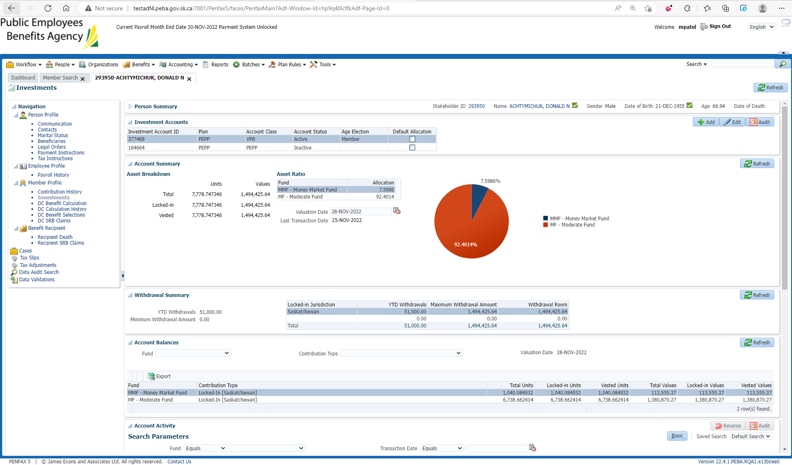

Current Scheduled withdrawal

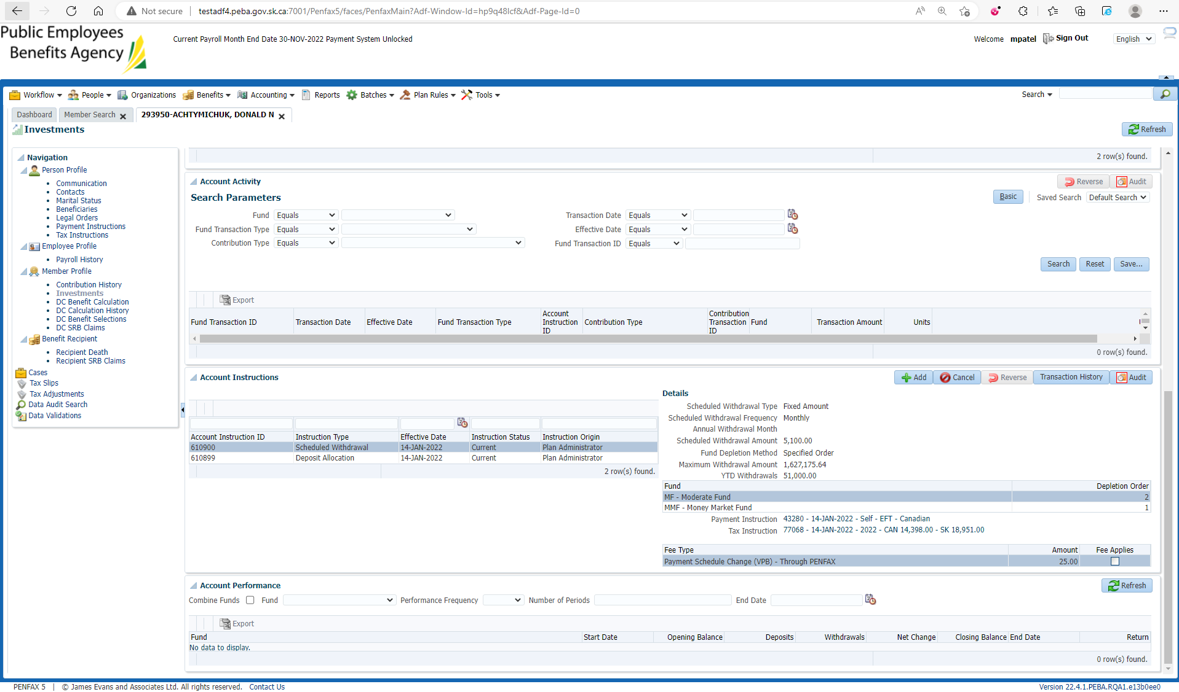

DC Benefit Selection🡪 Add DC Benefit Selection

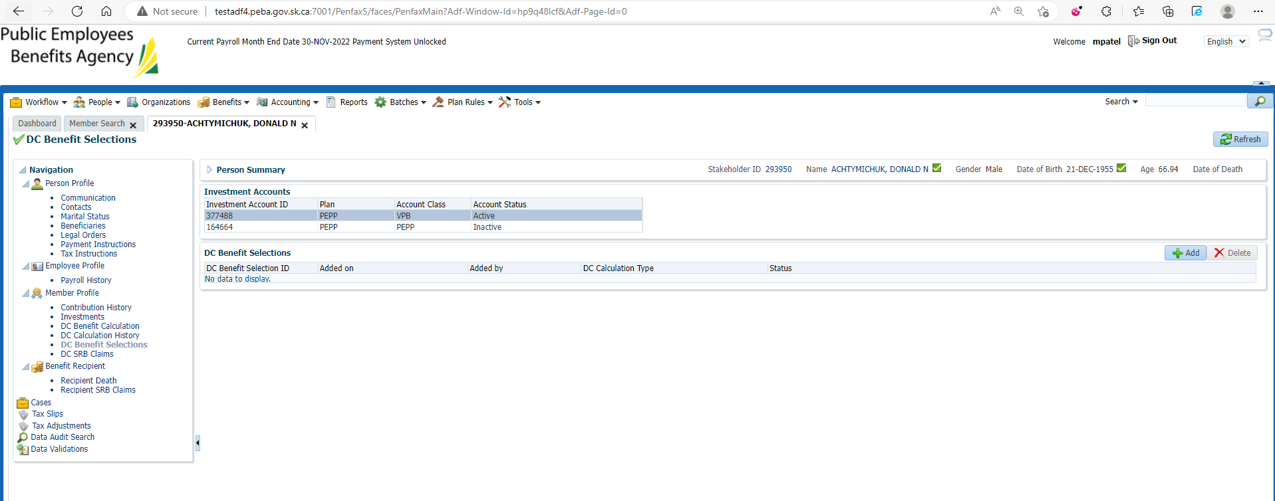

Next

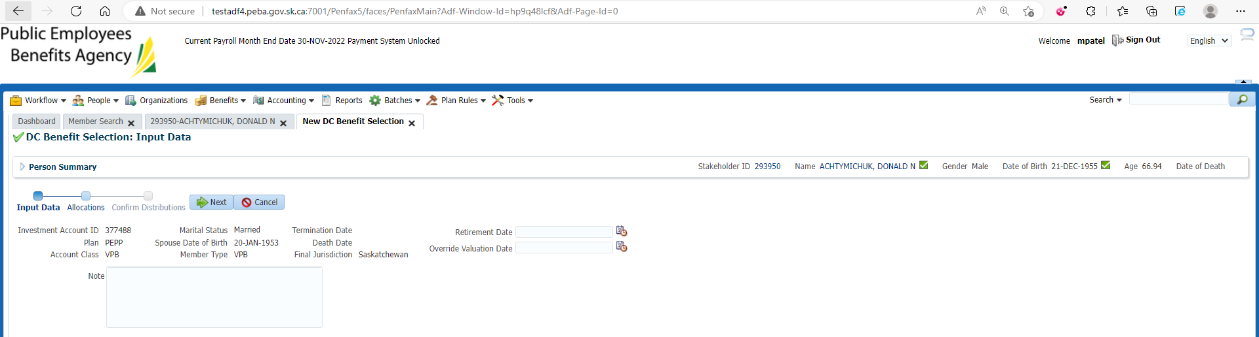

Add Allocation for VPB Lump sum payment and Save

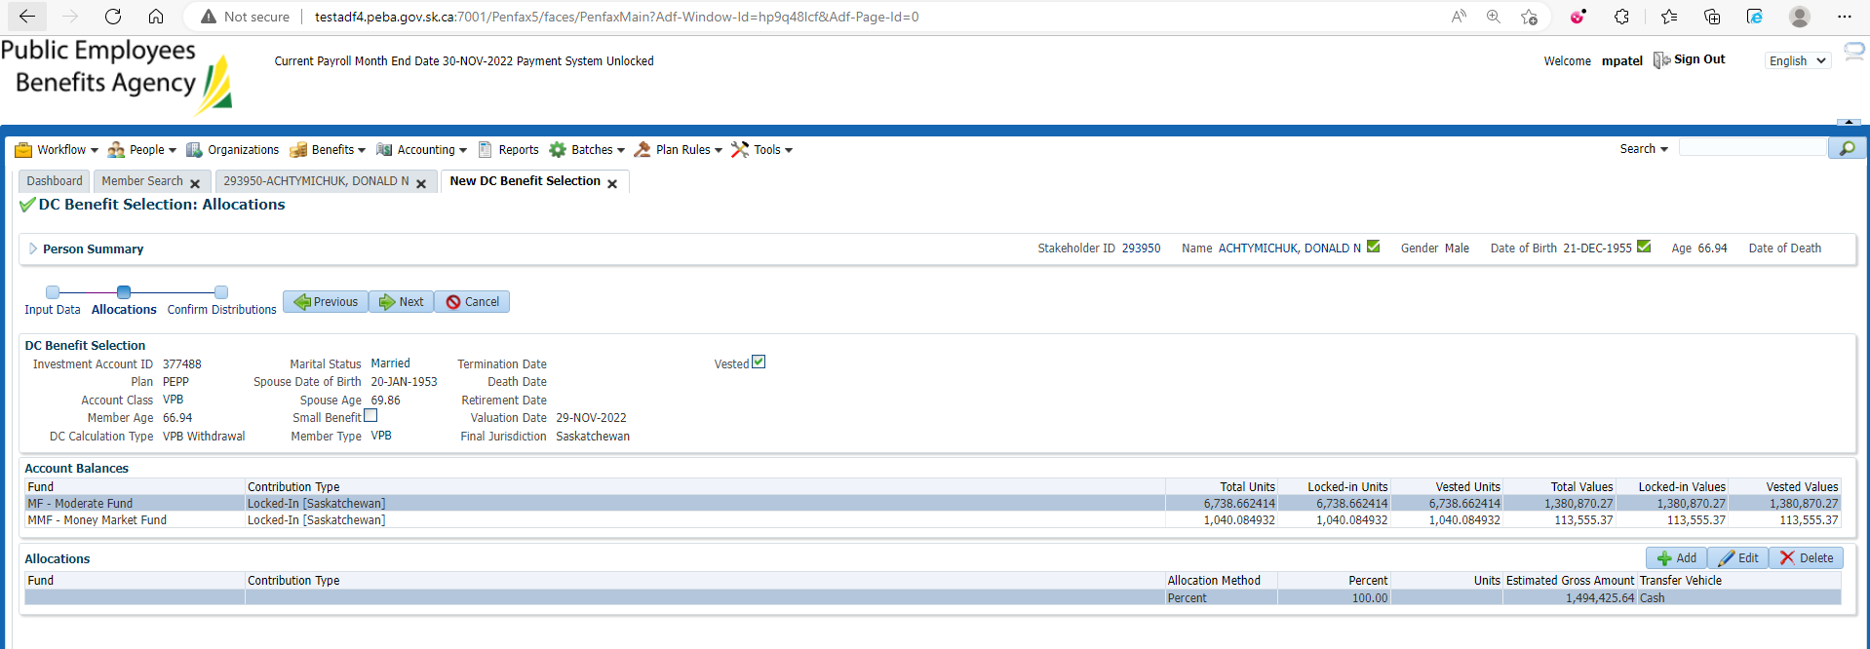

Submit for Approval and Approve it

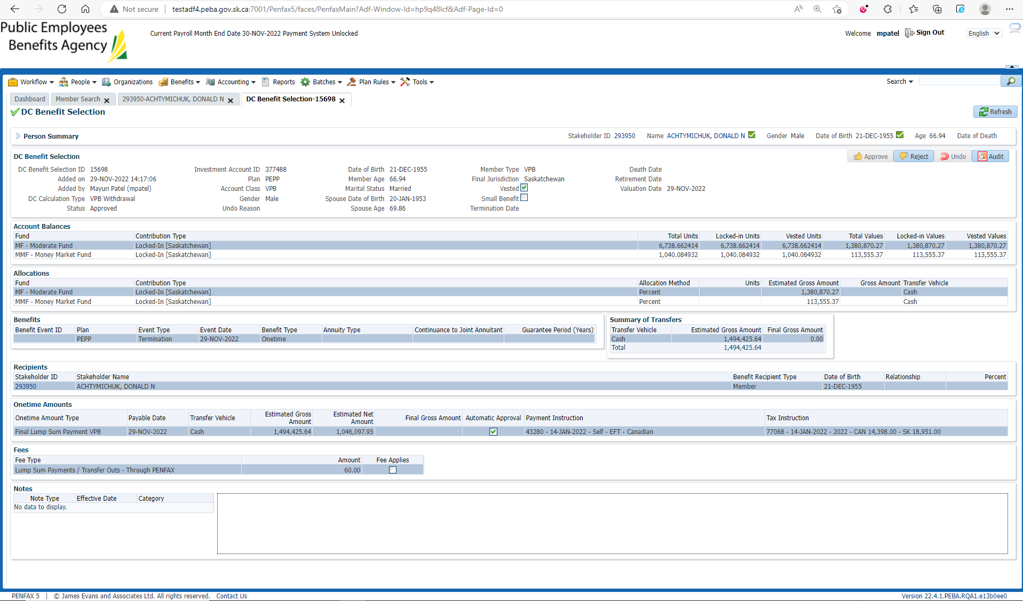

After Overnight PIT batch

Open that member Profile

Under Benefit recipient Menu🡪Onetime amount Tab

VPB lump sum Payment is paid out

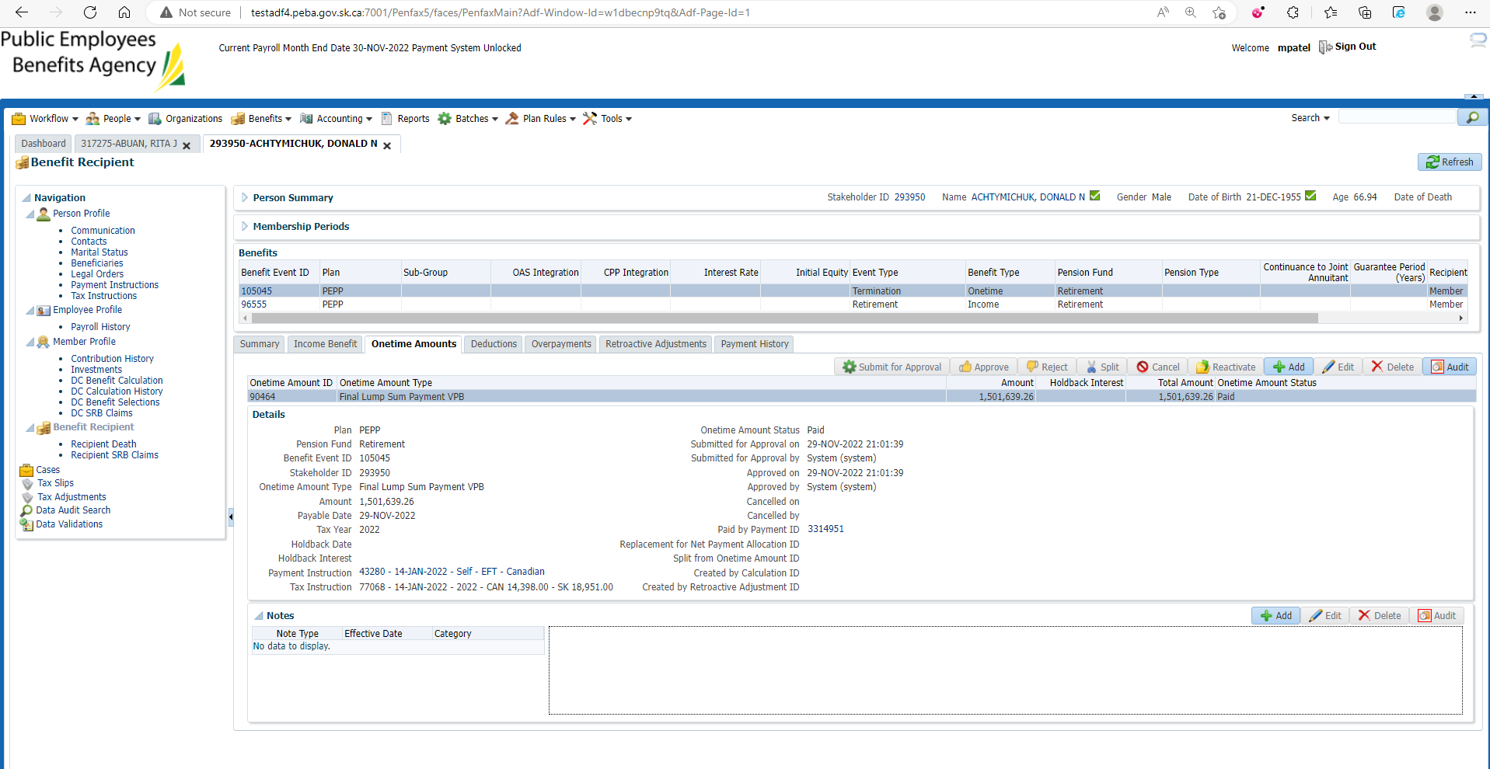

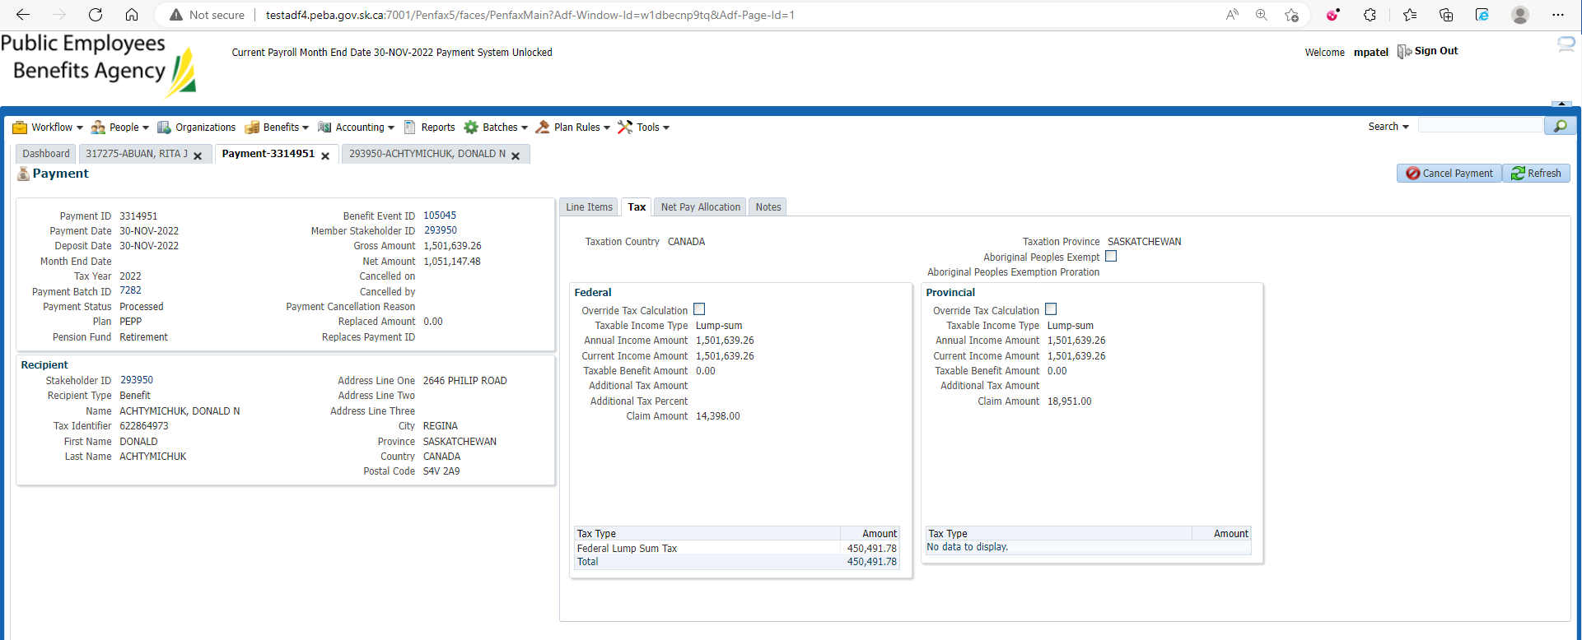

Under Income Benefit Tab Monthly payment for that month has been processed

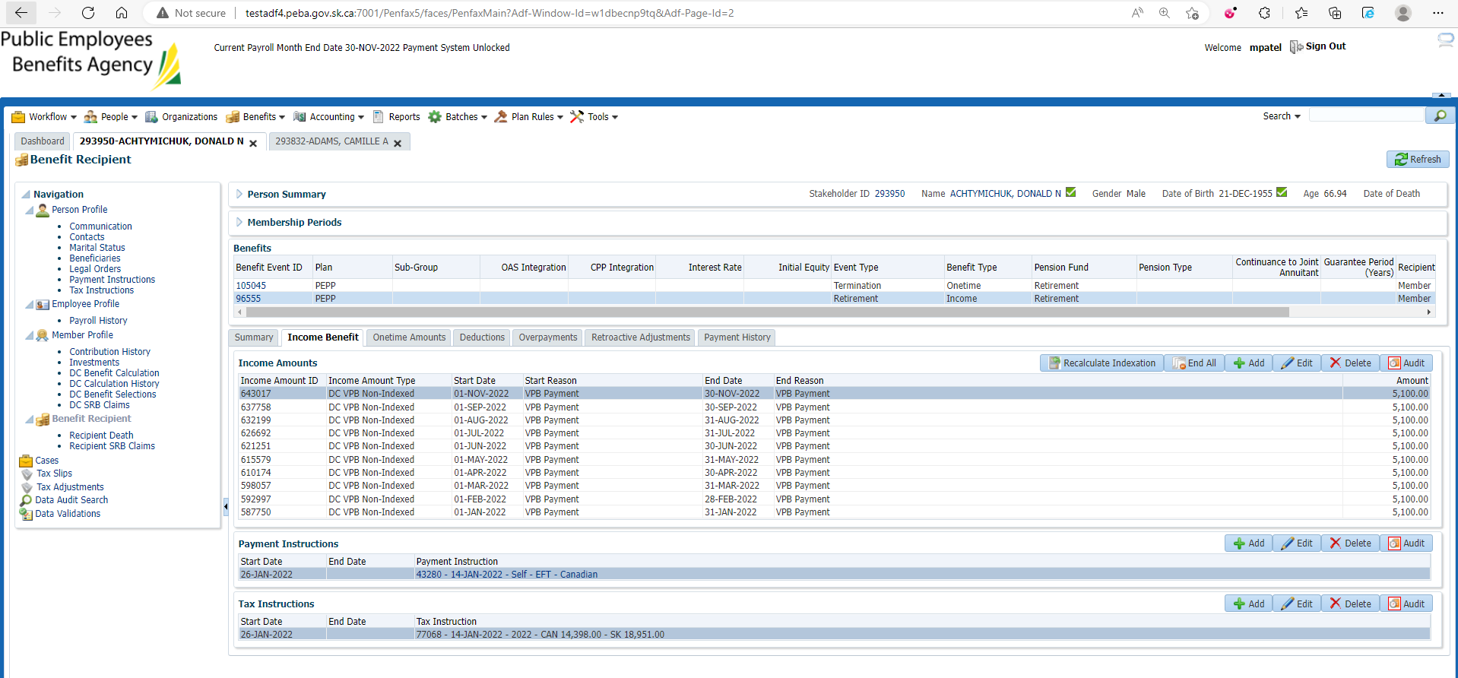

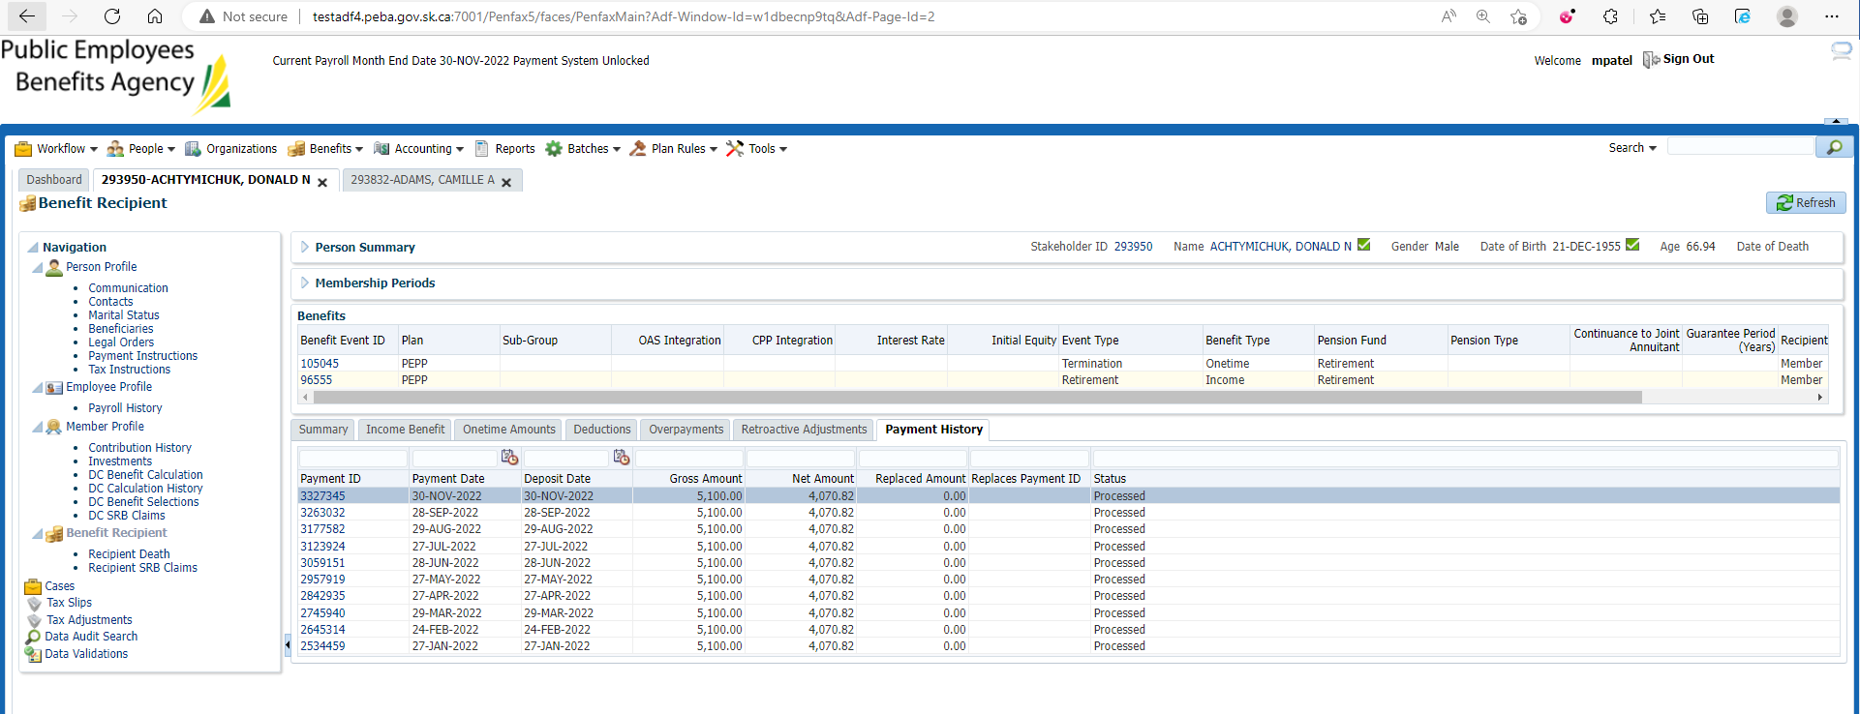

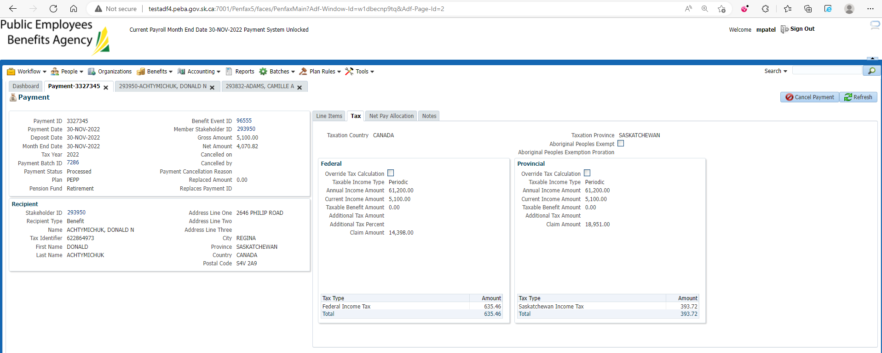

Investments🡪Account Activity

Schedule withdrawal and VPB Lump sum payment transaction are processed

Same steps processed through PENWEB

